**ER Diagram**

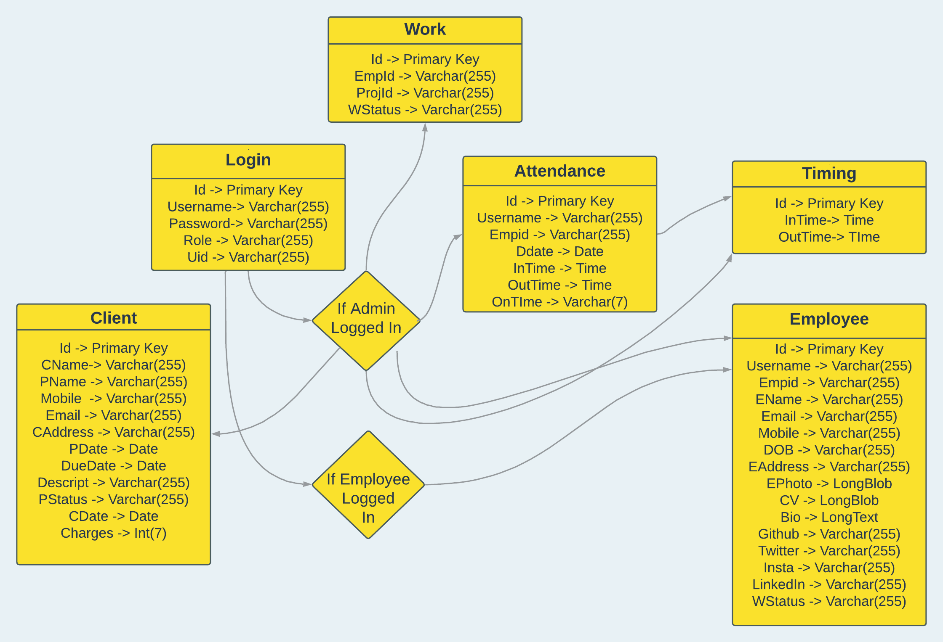

**Work table** :

Id, Empid, Projid, WStatus

This table contains about all the currently working and completed project by each Employee.

**Login** :

id, username, password, role, uid

This table contains all the necessary data that are needed and related for authentication.

**Client** :

id, CName, PName, Mobile, Email, CAdress, PDate, DueDate, Descript, PStatus, CDate, Charges.

This table contains data regarding all the clients and their projects.

**Employee** :

Id, Username, Empid, Email, EName, Mobile, DOB, EAddress, EPhoto, CV, Bio, Github, Twitter, Insta, Linkedin, Wstatus.

This table will have all the information of an employee and his/her social IDs.

**Attendance** :

Id, username, empid, Ddate, InTime, OutTime, OnTime

This table has the attendance related information.

**Timing** :

id, outTime, inTime

This table contains the company’s working time and info.

**Class Diagram**

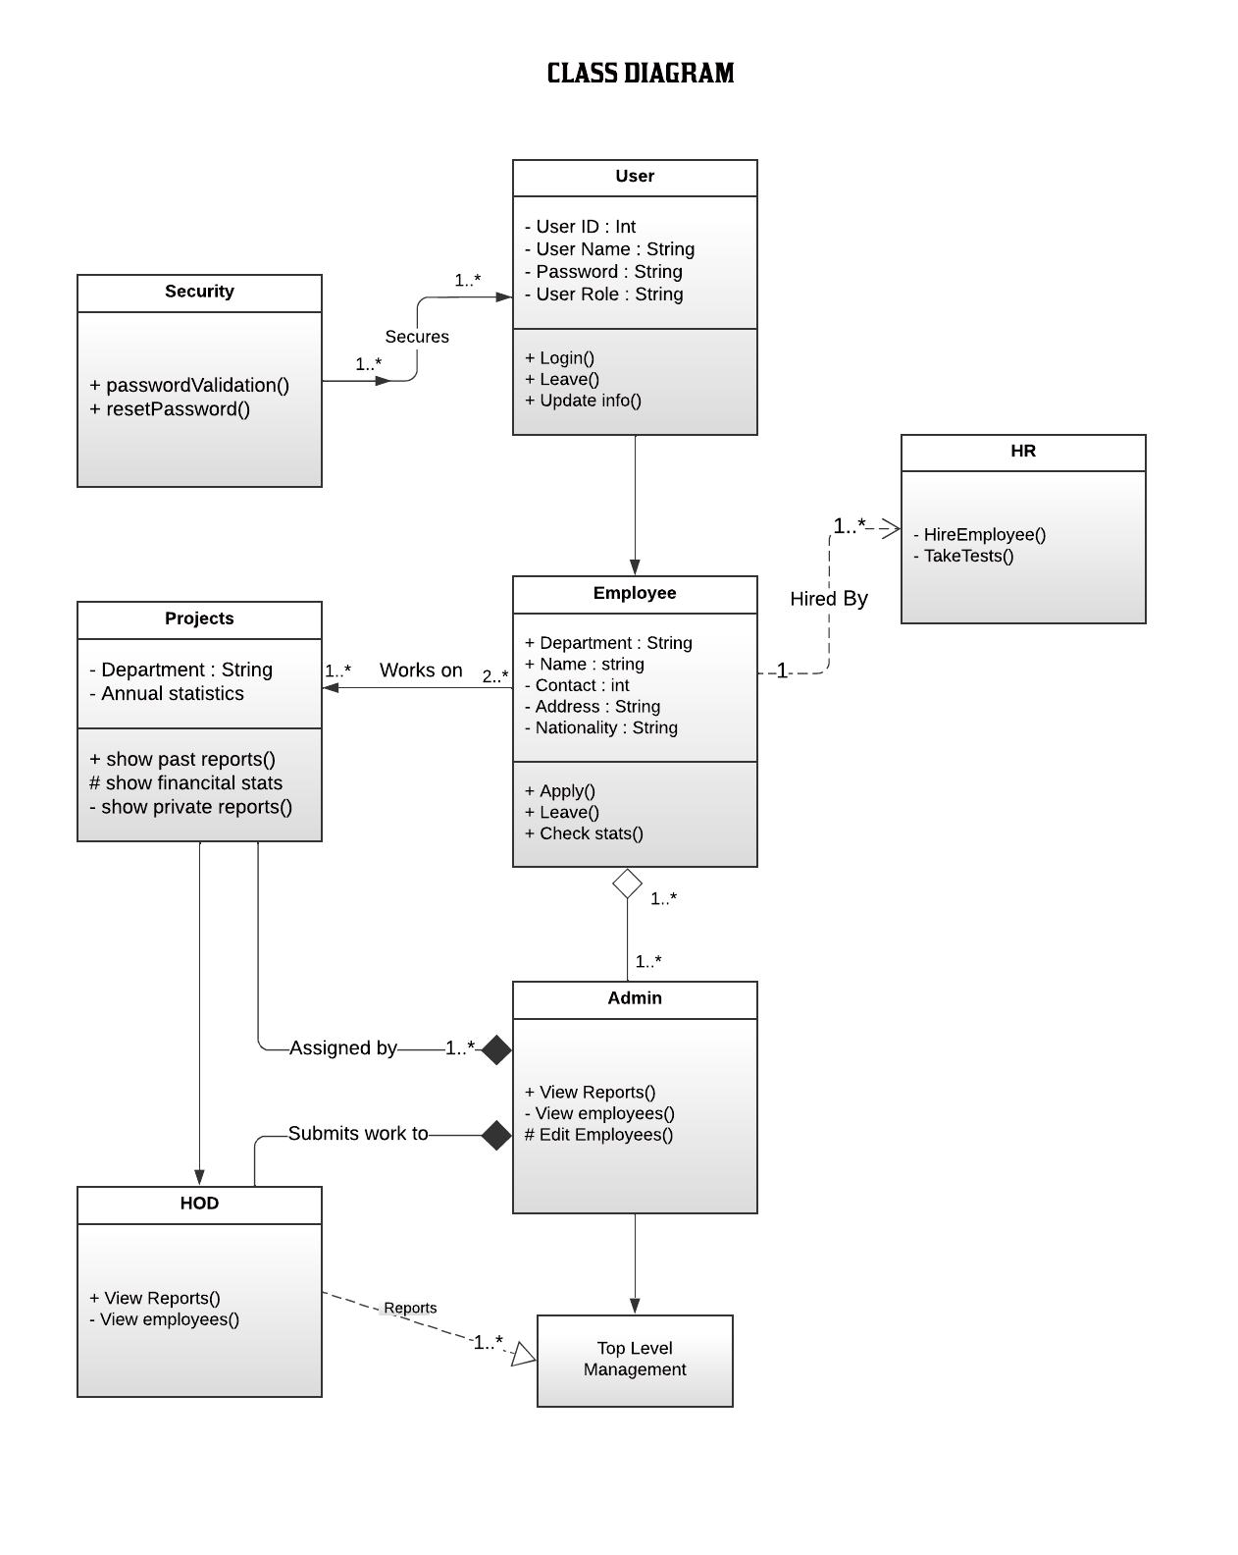

**DFD Diagram**

**Level 0**

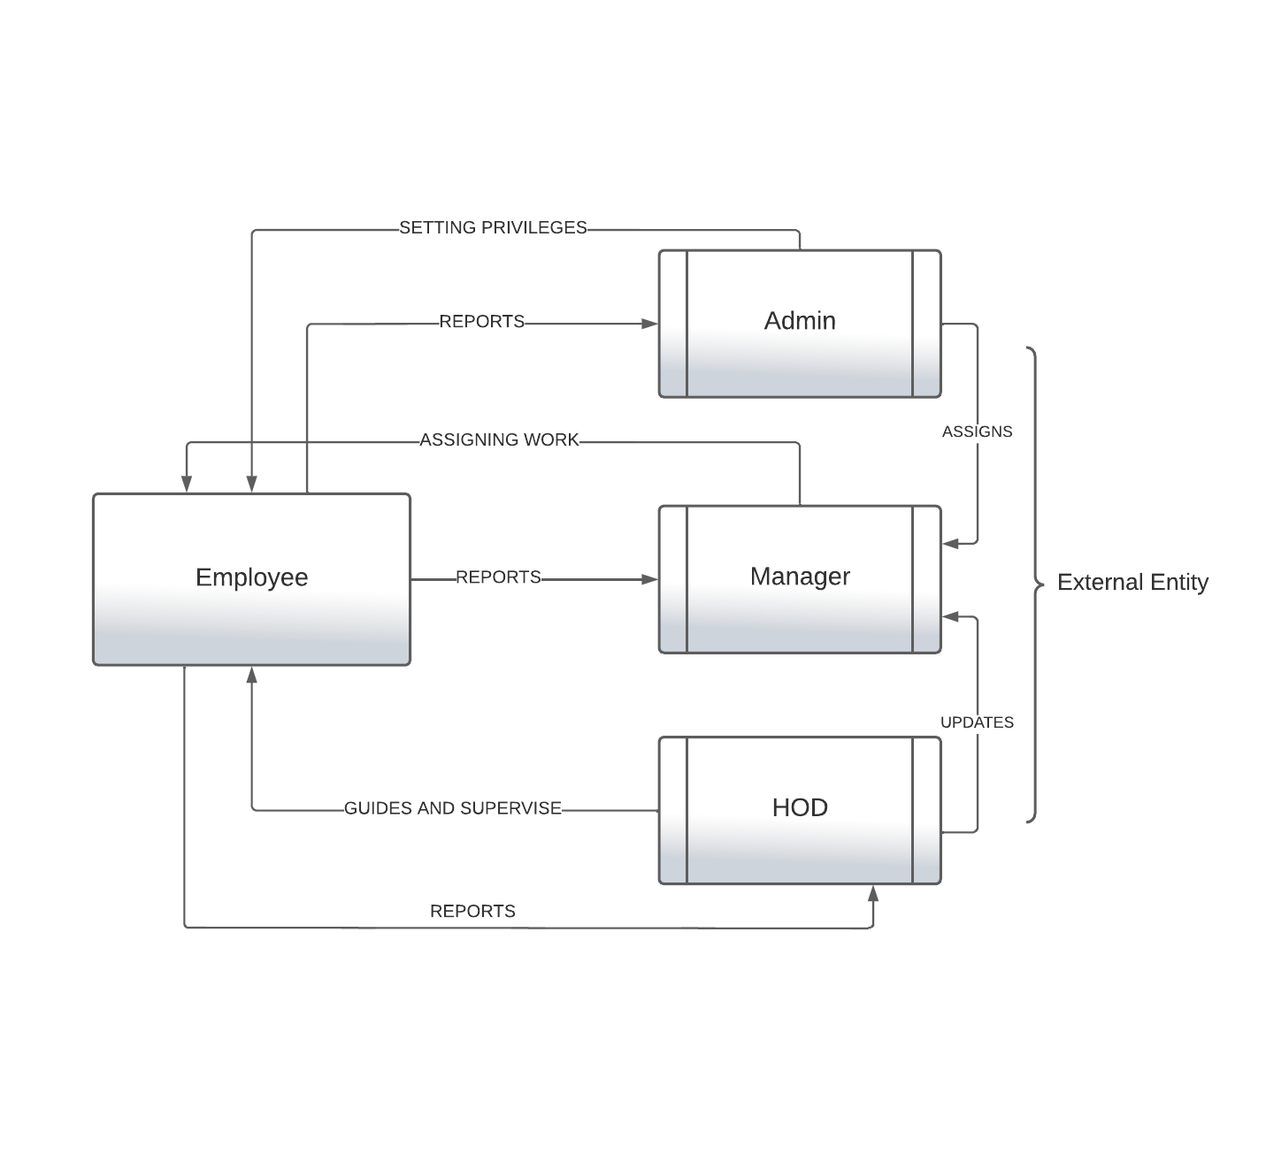

**DFD Diagram**

**Level 1**

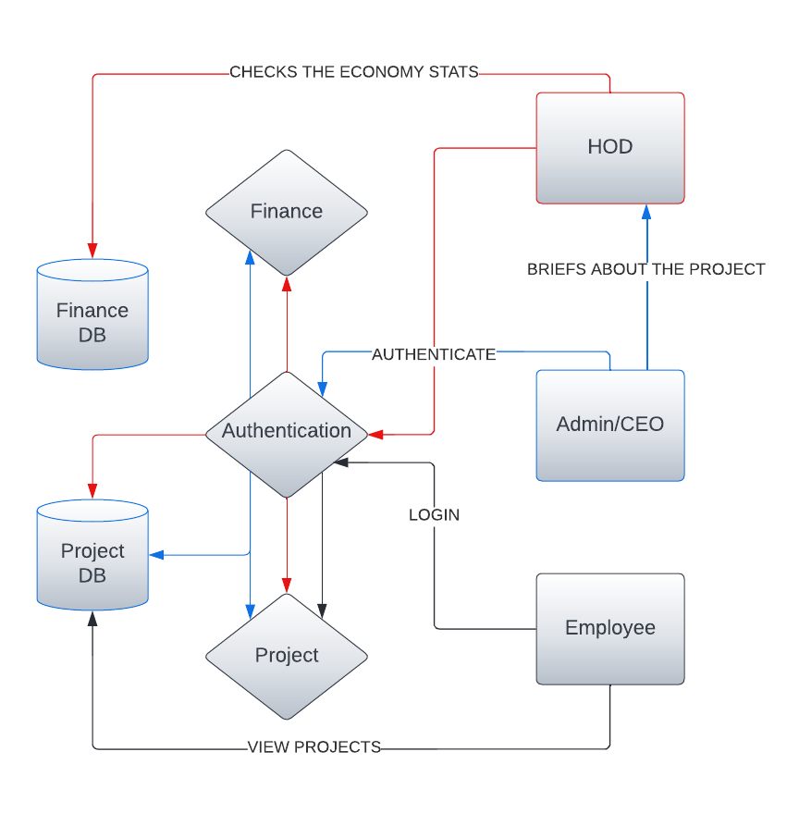

**DFD Diagram**

**Level 2**

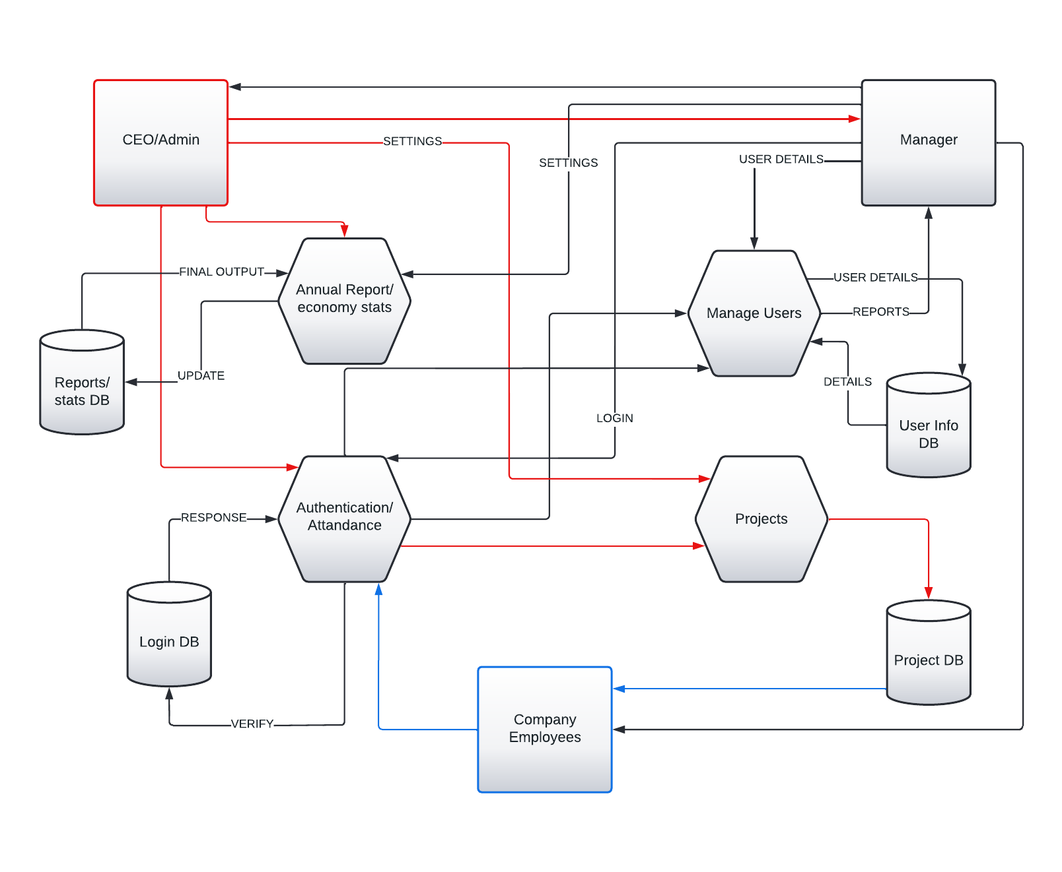

**Features**

1. Admin/ Top Level Management –
   1. View Employee
   2. Edit Employee
   3. Accept or Reject projects
   4. Time management.
   5. View and keep backups
   6. Secured platform
2. Employee –
   1. Edit profile
   2. View tasks
   3. Backups (Work, Finance, Status)
   4. Secured platform
   5. Writes and Mantains Blog
   6. Access to (some) previous projects
   7. Use snippets of old project
3. Finance Department –
   1. View current finance stats
   2. Keeps track of all incoming project
   3. Keeps track of all profits and loss
   4. Average profits and loss
   5. Secured platform
   6. Invoice generator
4. Human Resource (HR) –
   1. Hire Employee
   2. Online MCQ test
   3. Secured platform
5. Manager –
   1. Assigns tasks
   2. Update tasks
   3. View employee
   4. Add employee to projects
   5. Updates to Admin
   6. Generates report
6. Security –
   1. Prepared statements
   2. Password reset (every month)
   3. Sanitization of user input
   4. File directory would be compared with base directory
   5. Two Factor Authentication
7. General Features –
   1. Blog system
   2. View and read previous projects
   3. GitHub based